Analog IC Design: Course Project
Instructor: Prof. Abhishek Srivastava
Rohan Gupta – 2020112022

Que1.
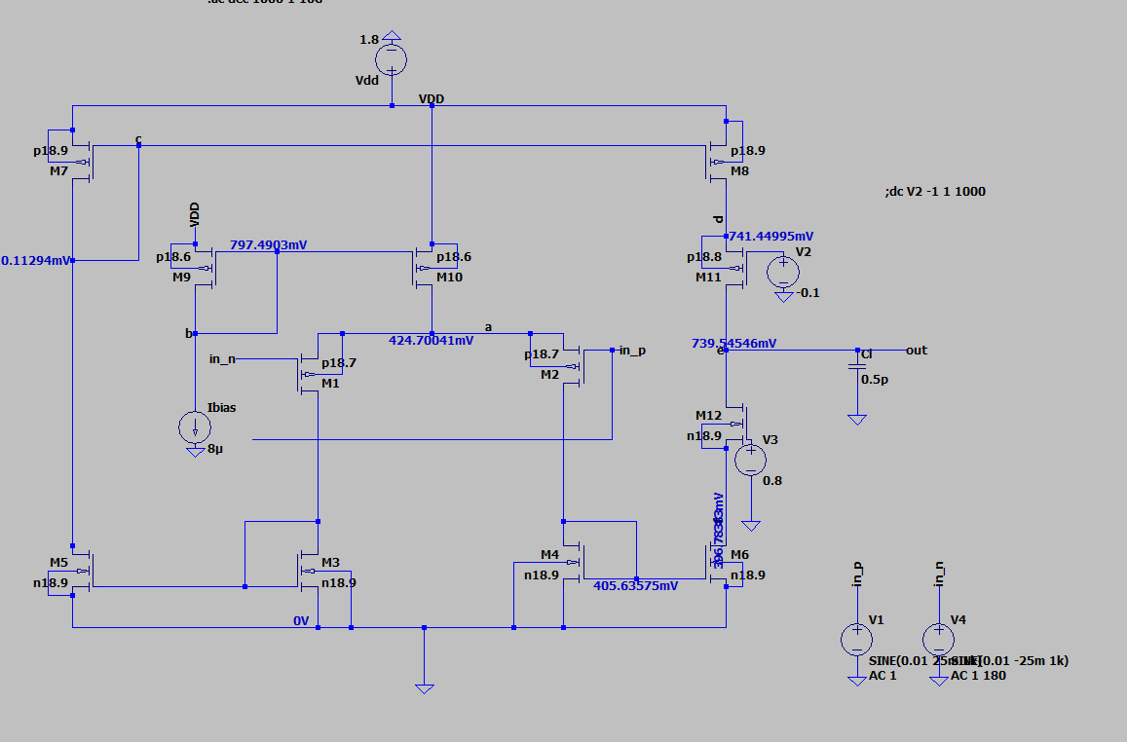
Que2.
Que3.
Devices | Type | W/L
M1,M2 | p18.7 | 80/0.18
M3,M4,M5,M6 | n18.9 | 27/3
M7,M8 | p18.9 | 2/9
M9,M10 | p18.6 | 1.2/1.2
M_cascN | n18.9 | 40/5
M_cascP | p18.8 | 90/1

